**Food ORDER & delivery application(foodhub)**

**Project Abstract**

**Version 1.0**

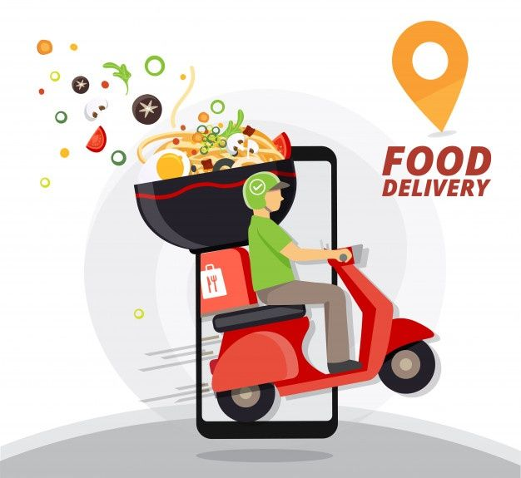

|  |  |  |  |
| --- | --- | --- | --- |
|  | Prepared By / Last Updated By | Reviewed by | Approved By |
| Name | Pratik Barahate  Surendra Babu Kudala  Ashok Pathuri |  |  |
| Role | POD Leader  POD Member  POD Member  (Sprint Wise Rotation) |  |  |
| Signature |  |  |  |
| Date | 04-01-2023 |  |  |

**Table of Contents**

1. Purpose of this document
2. Business Case
   1. Problem Statement
   2. Project Description
   3. Project Modules/Services
   4. Benefits
3. Appendices
   1. Glossary
   2. Other
4. Terms & Conditions
5. Change Log

# Purpose of this document

This document provides an overview about the business need and the solution that can be provided to fulfil the objective.

# Business Case

## Problem Statement

Every Student, Employed who stays far from his home for their studies or job purpose always faced this common issue in their lifestyle of not getting daily good quality food at a fair price point, PG Hostels food usually lacks quality therefore people need to depend and roam around the areas to get the food from restaurants and mess services which offers the food but at really high price point which may not be feasible specifically to the students staying at PG Hostels.

## Project Description

This is a microservice based application which can be used for food delivery for users/customers at PG Hostels. Therefore, the users will be able to order food on monthly/weekly basis either by selecting pre-defined plans or by customizing plans as per needs of the users.

The specialty of this application is that it will be beneficial for both PG users as well as for Food Vendors as the daily meals will be provided for the users at a discounted price point.

Along with providing the services to PG Hostel users, we will also provide the normal food delivery options for normal users.

## Project Modules/Services

Service 1: Customer-Subscriber Service

1. In this service the customer/user will be able to register himself with the application and will be able to update his details, delete his details and other operations.
2. This service will contain the registration of subscribers, and their selection of subscription plans or customization of their plans after their registration.

Service 2: Food Service

This service will contain the overall food menu options such as adding into food menu, updating the existing menu and deleting the unpopular menu options for admin user. It will also contain subscribers’ food plans.

Service 3: Order Service

This service will process the order details of subscribers as well as the order details for normal single order by the normal customers.

Service 4: Billing Service

This service will do all the billing of the orders being processed by order service from the customers. And will generate the invoice and these orders will further being processed to the delivery service for delivery.

Service 5: Delivery Service

This service will allot the orders being confirmed by the billing service to the available delivery person and will check the status of the orders constantly until they being delivered.

## Benefits

Benefits for User/Customer:

1. It will be beneficial for users who stays at PG Hostels.
2. PG Users will be able to select from pre-defined meal plans as per their pocket.
3. Meal plans will be available for discounted price points.
4. Weekly/Monthly plans can be selected as required.

# Appendices

## Glossary

|  |  |
| --- | --- |
| **Acronyms** | **Definitions** |
|  |  |

## Other

# Terms & Conditions

***Disclaimer: Please do not circulate or distribute this document outside of Cognizant Network, we have a Zero Tolerance Policy. Kindly adhere to 100% Compliance at all times.***

# Change Log

*Please note that this table needs to be maintained even if a Configuration Management tool is used.*

|  |  |  |  |  |
| --- | --- | --- | --- | --- |
| Version Number | Changes made | | | |
| V<n.n> | *<If the change details are not explicitly documented in the table below, reference should be provided here>* | | | |
| Page no | Changed by | Effective date | Changes effected |
|  |  |  |  |
|  |  |  |  |
|  |  |  |  |
|  |  |  |  |